Dental AR Sensor Setup

# Configuring Sensor

Configuring the sensor requires a Bluetooth enabled Windows computer

1. Download the sensor control software, OpenMAT, from:

<https://www.lp-research.com/support/>

1. Pair the LMPSB2 device with the laptop.
2. Open OpenMAT, and click “Add Sensor”, selecting the paired sensor

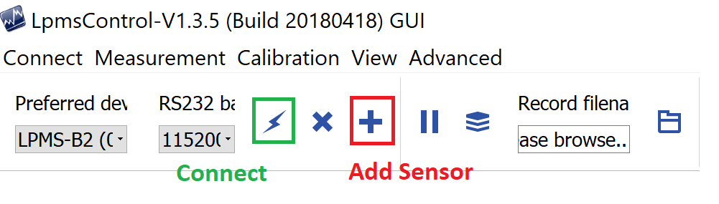

1. Press the “Connect” button – A device should appear under “Connected Devices” in the left hand column

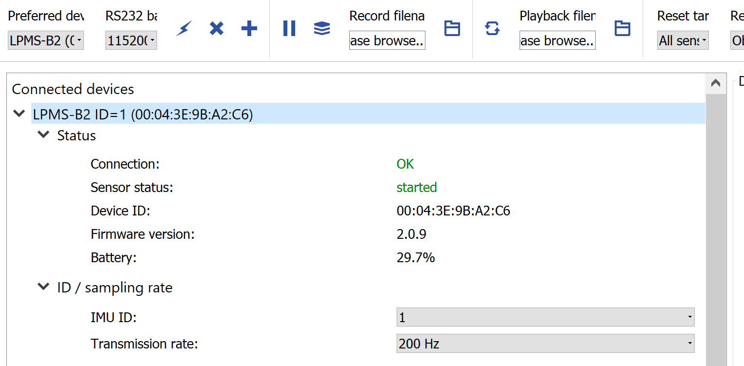

1. Make sure that the IMU ID is set to 1
2. Under the Filter section, set the Filter mode to Gyr Only. The remaining settings can be set as required for internal precision

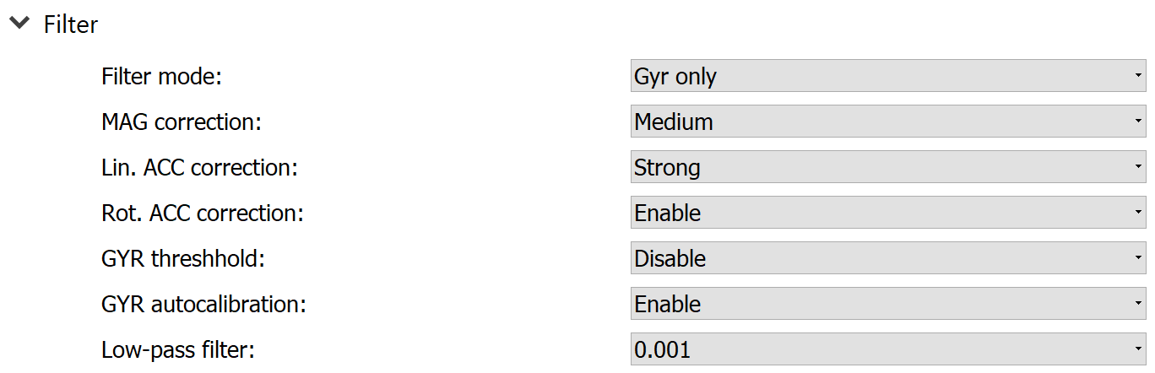

1. Under the Data section, ensure that ONLY Quaternion is selected, and the LPBUS data mode is set to 32-bit floating point.

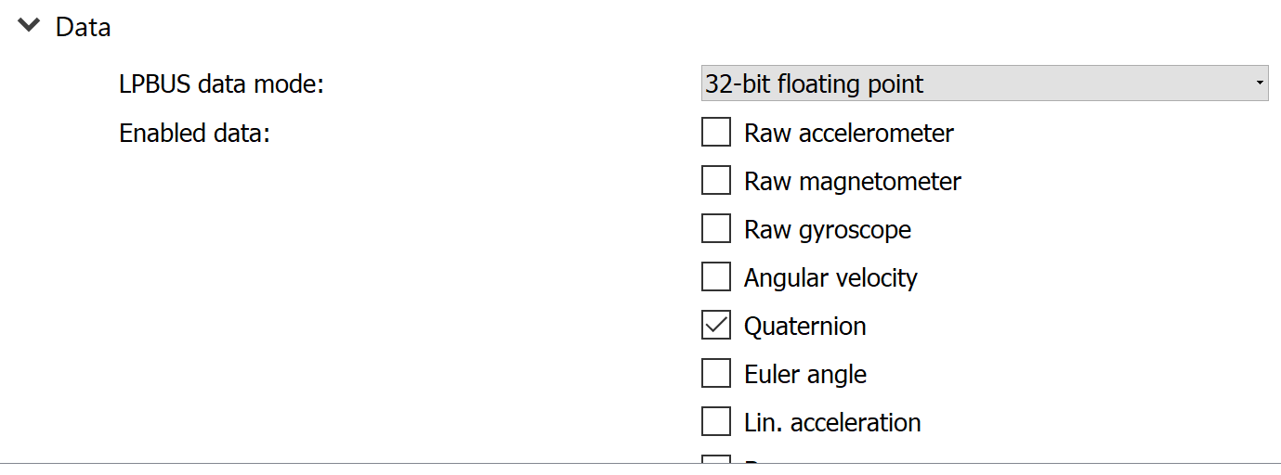

The sensor configuration is now complete. To verify that it was successful, select “Data View” by pressing the target icon in the top right, and ensuring that as you rotate the device, the Quaternion readings change. ALL other readings should remain 0. If they do not, you must check the Data section and disable any additional data selections.

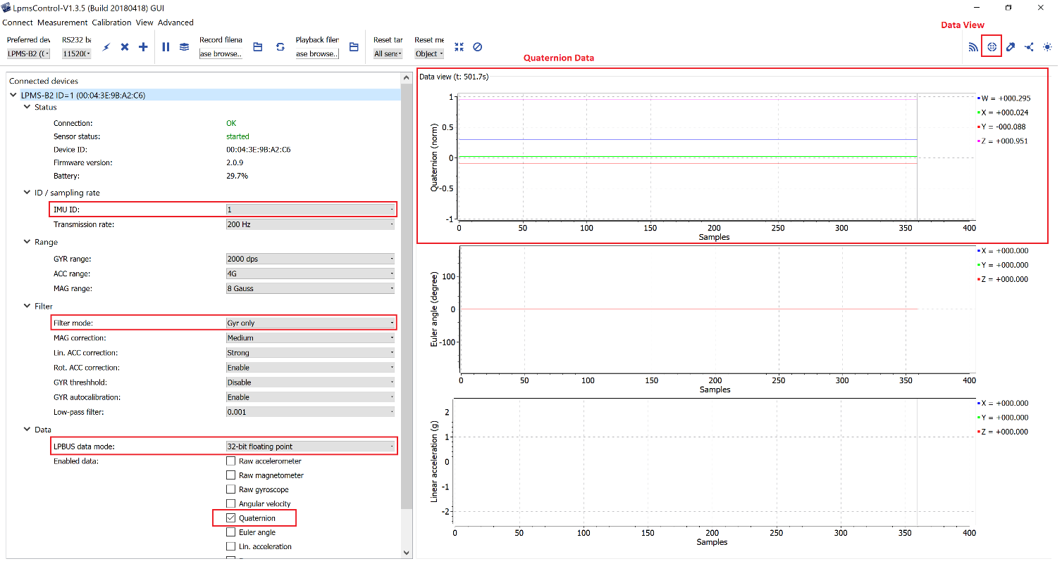

# Connecting sensors to glasses

1. Pair the LPMSB2 device with the AR Glasses (through Settings -> Bluetooth)
2. Open the DentalAR application
3. Navigate to the Settings menu
4. Select the “Connect Sensor” option. This should open a dialogue box showing all paired Bluetooth device.
5. Select the LMPSB2 device from the paired devices list

The Sensor is now connected to the glasses. The connection to DentalAR is stored in local persistent memory (via MAC address), so this process should not need to be repeated unless a new sensor is required, or the app is reinstalled.

Entering the PIP screen should automatically trigger the sensor to begin sending information. Leaving the PIP screen will send the sensor to sleep.